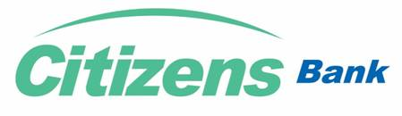
Citizens USD E-com Card Request & Self-Declaration Form
Date:___/___/_____
To,
The Manager,
Citizens Bank International Ltd.,
………………………… Branch
Subject: Request for USD E-Com Card
Dear Sir/Madam,
I/we would like to kindly request for USD E-com Card against my/our NPR Saving/Current Account maintained at Citizens Bank International Limited for making online payments internationally.
Account Name: Account Number:
Account Type: Permanent Account Number (PAN):
Mobile Number: Email ID:
Requested Card Top up Amount (Max. USD 500):
I/We hereby declare that, I/we have not availed any USD E-com Card or similar card from any other Banks or Financial Institution and will not use the card for online purchase of any asset/property or goods restricted by Nepal Government and will bind to all the rules and regulations as per the circular issued by NRB. I/We also declare that, I/We have not been involved in any type of criminal or money laundering activities. I/We also declare that all the information submitted along with this application form are true and correct to the best of my/our knowledge and belief and authorize the Bank to verify any information from whatever source it may consider appropriate. I/We will be held self-responsible for the same without any obligation towards the bank and its staffs.
I/We hereby give my/our consent to debit my/our above mentioned account for deducting equivalent NPR amount including all the charges levied for the issuance of USD E-com Card.
------------------------------
Authorized Signature
Customer Name:
For bank’s Use Only
Application Received/Verified By:
Name: Designation: Stamp:
Date: Signature:

